Get me the IP address of a particular domain (guvi.in).

ubuntu@ip-172-31-37-228:~$ nslookup guvi.in

Server: 127.0.0.53

Address: 127.0.0.53#53

Non-authoritative answer:

Name: guvi.in

Address: 172.67.70.207

Name: guvi.in

Address: 104.26.4.88

Name: guvi.in

Address: 104.26.5.88

Name: guvi.in

Address: 2606:4700:20::681a:458

Name: guvi.in

Address: 2606:4700:20::ac43:46cf

Name: guvi.in

Address: 2606:4700:20::681a:558

ubuntu@ip-172-31-37-228:~$

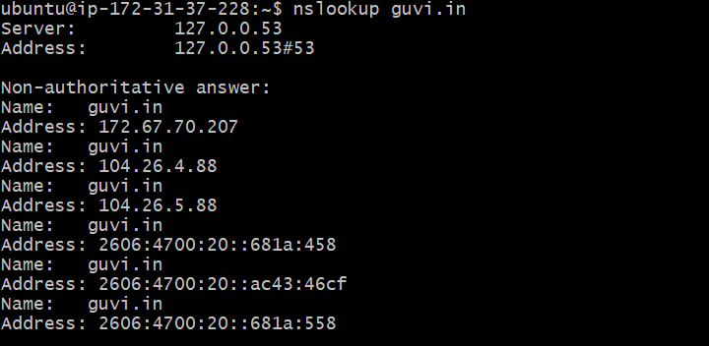

=================================================================

How do I find my CPU/memory usage of my server?

ubuntu@ip-172-31-37-228:~$ htop

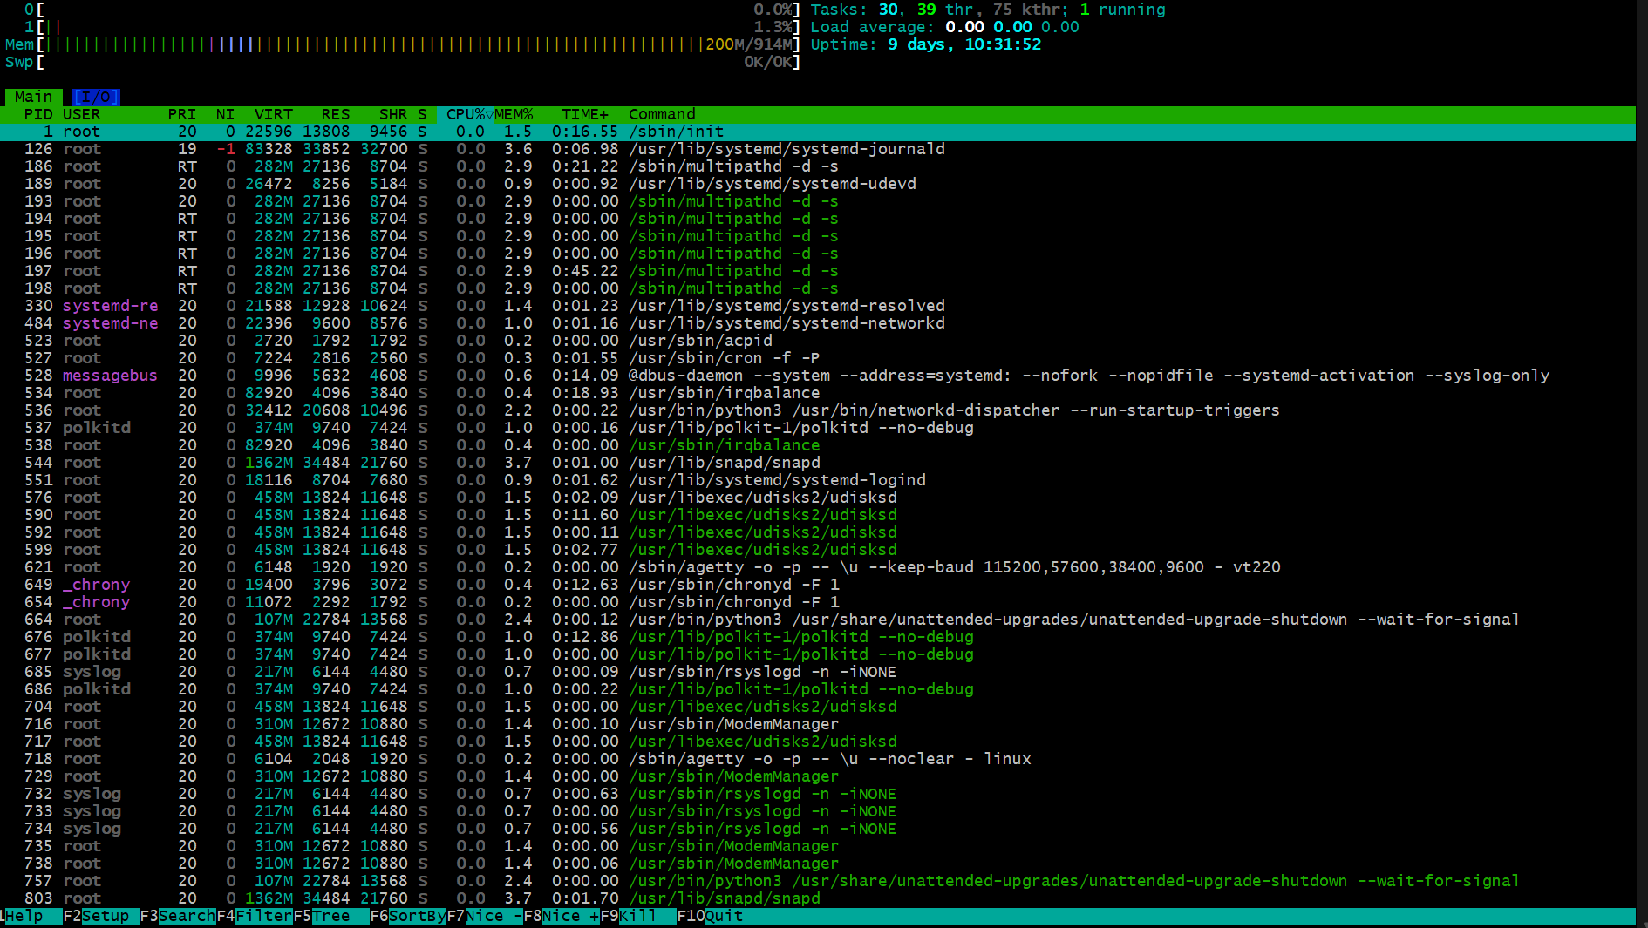

Test the connectivity between 2 nodes?

ubuntu@ip-172-31-37-228:~$ ping guvi.in

PING guvi.in (104.26.5.88) 56(84) bytes of data.

64 bytes from 104.26.5.88: icmp_seq=1 ttl=54 time=3.02 ms

64 bytes from 104.26.5.88: icmp_seq=2 ttl=54 time=3.05 ms

64 bytes from 104.26.5.88: icmp_seq=3 ttl=54 time=3.06 ms

64 bytes from 104.26.5.88: icmp_seq=4 ttl=54 time=3.12 ms

64 bytes from 104.26.5.88: icmp_seq=5 ttl=54 time=3.03 ms

64 bytes from 104.26.5.88: icmp_seq=6 ttl=54 time=3.12 ms

64 bytes from 104.26.5.88: icmp_seq=7 ttl=54 time=3.07 ms

64 bytes from 104.26.5.88: icmp_seq=8 ttl=54 time=3.13 ms

64 bytes from 104.26.5.88: icmp_seq=9 ttl=54 time=3.07 ms

64 bytes from 104.26.5.88: icmp_seq=10 ttl=54 time=3.05 ms

64 bytes from 104.26.5.88: icmp_seq=11 ttl=54 time=3.12 ms

64 bytes from 104.26.5.88: icmp_seq=12 ttl=54 time=3.07 ms

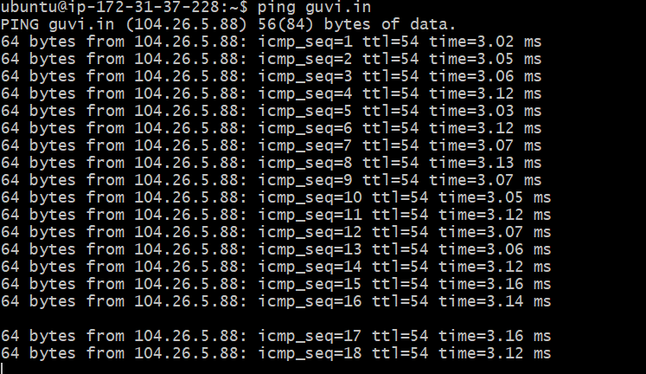

Deployed an application in guvi.com:9000, and logs show my app is running, but I’m unable to view the page. Check whether my port is open or not ?

ubuntu@ip-172-31-37-228:~$ traceroute guvi.in 9000

Command 'traceroute' not found, but can be installed with:

sudo apt install inetutils-traceroute # version 2:2.4-3ubuntu1, or

sudo apt install traceroute # version 1:2.1.5-1

ubuntu@ip-172-31-37-228:~$ sudo apt install traceroute

Reading package lists... Done

Building dependency tree... Done

Reading state information... Done

The following NEW packages will be installed:

traceroute

0 upgraded, 1 newly installed, 0 to remove and 31 not upgraded.

Need to get 60.5 kB of archives.

After this operation, 162 kB of additional disk space will be used.

Get:1 http://eu-north-1.ec2.archive.ubuntu.com/ubuntu noble/universe amd64 traceroute amd64 1:2.1.5-1 [60.5 kB]

Fetched 60.5 kB in 0s (1040 kB/s)

Selecting previously unselected package traceroute.

(Reading database ... 101159 files and directories currently installed.)

Preparing to unpack .../traceroute_1%3a2.1.5-1_amd64.deb ...

Unpacking traceroute (1:2.1.5-1) ...

Setting up traceroute (1:2.1.5-1) ...

update-alternatives: using /usr/bin/traceroute.db to provide /usr/bin/traceroute (traceroute) in auto mode

update-alternatives: using /usr/bin/traceroute6.db to provide /usr/bin/traceroute6 (traceroute6) in auto mode

update-alternatives: using /usr/bin/lft.db to provide /usr/bin/lft (lft) in auto mode

update-alternatives: using /usr/bin/traceproto.db to provide /usr/bin/traceproto (traceproto) in auto mode

update-alternatives: using /usr/sbin/tcptraceroute.db to provide /usr/sbin/tcptraceroute (tcptraceroute) in auto mode

Processing triggers for man-db (2.12.0-4build2) ...

Scanning processes...

Scanning linux images...

Pending kernel upgrade!

Running kernel version:

6.8.0-1026-aws

Diagnostics:

The currently running kernel version is not the expected kernel version 6.8.0-1027-aws.

Restarting the system to load the new kernel will not be handled automatically, so you should consider rebooting.

No services need to be restarted.

No containers need to be restarted.

No user sessions are running outdated binaries.

No VM guests are running outdated hypervisor (qemu) binaries on this host.

ubuntu@ip-172-31-37-228:~$ traceroute guvi.in 9000

traceroute to guvi.in (172.67.70.207), 30 hops max, 9000 byte packets

1 240.3.96.14 (240.3.96.14) 2.950 ms 240.3.96.13 (240.3.96.13) 2.940 ms 240.3.96.12 (240.3.96.12) 3.056 ms

2 240.3.96.18 (240.3.96.18) 2.677 ms 240.3.96.17 (240.3.96.17) 2.679 ms 240.3.96.27 (240.3.96.27) 2.697 ms

3 99.83.93.94 (99.83.93.94) 2.870 ms 2.801 ms 3.107 ms

4 * * *

5 * * *

6 * * 172.67.70.207 (172.67.70.207) 3.205 ms

ubuntu@ip-172-31-37-228:~$

